Program of study (courses, assignments, course format).

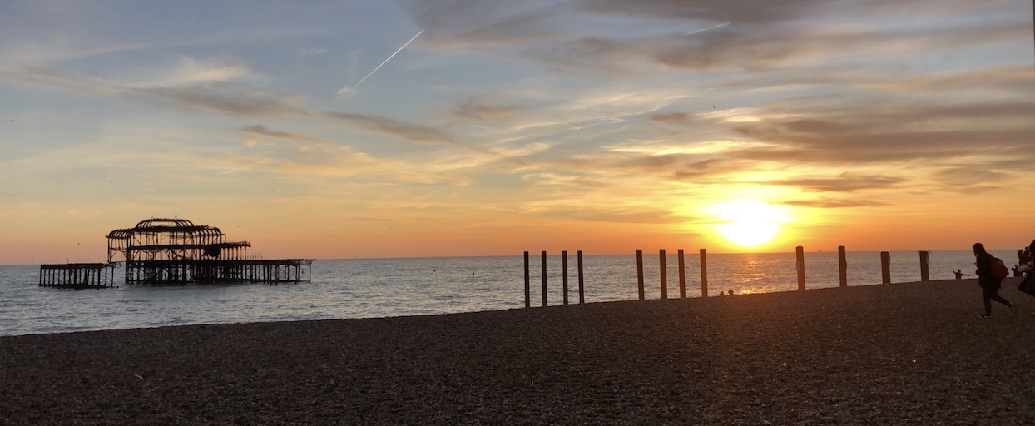

I am currently completing my third year of International Management studies abroad at the University of Brighton in England. In Brighton international students have a total of six classes that total approximately 9-11 hours of lecture and seminar time a week. Things work a little differently that back home at Telfer. For starters, the person who lectures is Called a Lecturer and not a professor. In England there is a distinction between the two (a professor is known to be a more respected professional who has earned the title). Additionally, there may be more than one lecturer per class and the team of lecturers will rotate from week to week depending on their expertise.
There is also a distinction to be made between a lecture and a seminar. A lecture can be compared to a typical telfer class where the lecturer usually has a slideshow and speaks to the material displayed. A seminar can be compared to a discussion group at Telfer but they also tend to be more engaged and hands on (your Business Communications class will come in handy in these). The International Business program at the University of Brighton is only a three year program and so unless your classmates have taken a year to complete an internship, they are in their third and final year of study. At this point in your university career lecturers expect a higher level of critical thinking. All finals except for one class are worth 100% of your grade and so learning to conduct sound academic research and learning to formulate a well backed opinion is crucial. In Digital Commerce there is no final assignment. The Assessments are broken down into four separate deliverables due throughout the semester. Additionally, a 40 hour online Goggle Garage course needs to be completed outside of class hours in order to receive the certification.
A significant component to consider when deciding which semester you would like to attend the University of Brighton is the coursed selection. Because the winter semester is much shorter than the fall semester and most of the courses offered in the fall are two parts with the second falling into the winter semester, there is a very limited amount of course options when applying to the winter semester. Additionally, some of the courses offered are the continuation of courses from the first semester which can make it more difficult to integrate into their classes.
The grading scheme can also be considered a little more challenging. An 80% on an assignment at the University of Brighton is equivalent to a 95-100% at Telfer. The following is a breakdown of my time table on exchange as well as a short description of each course:

 | Monday | Tuesday | Wednesday | Thursday | Friday
9:00 – 10:00 | No Classes |  |  | Lecture & Seminar – Purchasing & E-Procurement | Lecture – Understanding Contemporary Britain
10:00 – 11:00
11:00 – 12:00 |  | Lecture – International Human Resources | Lecture & Seminar – Understanding Comparative Employee Relations | Lecture & Workshop* – Small Business & Entrepreneurship
12:00 – 13:00 |  | Seminar – International Human Resources
13:00 – 14:00 |  |  |  | Lecture & Seminar** – Digital Commerce
*This class is not run for the entirety of the semester. Most of the material is presented in the first 3 lectures and the subsequent ones are workshops used to work on the final assignment with the guidance of the lecturer. It is not mandatory to attend the workshops.
**This class has three lectures dedicated to guided discussions on various topics within the digital commerce industry.

The timetable

- Application Deadline to go abroad: January 31st 2018
- Selection day: March 1st 2018March 29th 2018
- *Deadline for application to the university as well as accommodations: October 15th 2018
- Accommodation acceptance letter: December 14th 2018
- University Offer and Acceptance Letter and course options: December 17th 2018
- **Accommodation registration: January 1st 2019
- Move in day for residence: February 3rd 2019
- Semester 2 Dates: February 4th 2019 - June 7th 2019
- Orientation Day: February 4th 2019
- First day of classes: February 5th 2019
- Easter break: April 1st 2019 – April 21st 2019
- Last day of classes: April 26th 2019
- Review period and final deadlines: May 2019
*Because the accommodation is not guaranteed and is assigned on a first come first serve basis, you should apply as soon as possible, I would recommend no later than early to mid-June.
**The accommodation can either be paid in full or in two installments. If you have the means to do so I would recommend paying the full amount so that there is no need to worry

Procedures to follow upon arrival, Services offered by the International Exchange Office of the host institution, Registration and course selection, Social activities.

I would recommend arriving 2-3 days before move in day and renting an Airbnb to have some time to get your bearings and to have time to get the some essentials for the first few days in the on campus accommodation. Because move-in day is on a Sunday and shops close early, it makes it especially difficult to try and get what is needed for the dorm on the day of. When accepting the accommodation offer, there is the option to add on a UniKit which is a box that includes the essentials for your dorm room. This being said, I do not recommend investing in one of these boxes. Some previous students may have left behind some supplies (especially when it comes to cookware) and the quality of the items is not ideal. Additionally, going on shopping your first shopping trips is also a great way to bond with your new flatmates.
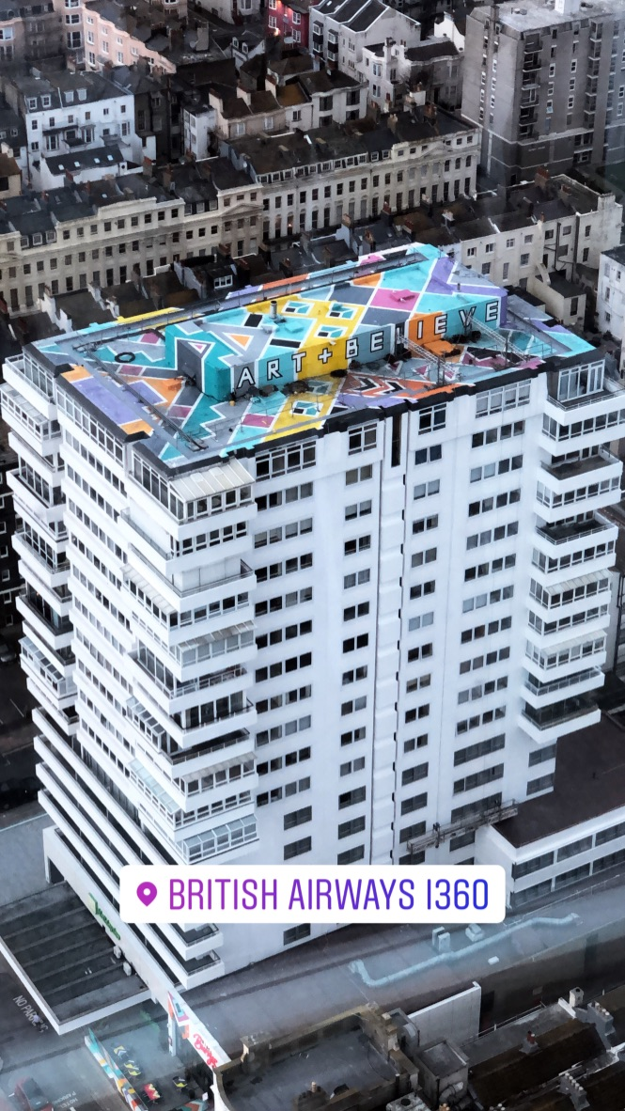
When you arrive to the airport (either Gatwick or Heathrow), you will need to get a train ticket to Brighton station. This will cost around 10.50 GBP. Once arrived at the Brighton train station there is a taxi station out front. The average taxi ride is around 15.00 GBP. It can be difficult to drag your4 luggage around town on public transportation as Brighton has a lot of hills. The Paddock Fields Halls of Residence are also set higher up in the city and are not a part of the central campus. Therefore a taxi is the best way to go.
Orientation day is when the class timetables are handed out. It is at this point that modifications can be made. If you do decide to do so, do not forget to contact the international Exchange office back at UOttawa. During this orientation the head of lecturers will also go over expectations and assignment guidelines (you may want to take a look at Harvard referencing). After this orientation session, there is a small tour of the main campus.
There is also an international student welcome meeting where the international exchange office representatives relay important information pertaining to on and off campus resources like healthcare and walk-in clinics in Brighton, important buildings and contacts, etc. Following this meeting, there is a scavenger hunt to explore the city and typical afternoon tea.

Budget outlining the cost of studying abroad

Expense | Cost
Airplane tickets | Approx. 1500-2000 CAD
Housing | 2660 GBP (4520 CAD)
Monthly travel costs | 48 GBP (82 CAD)
Monthly meal costs (groceries and eating out) | 250 GBP (425 CAD)
Dorm room furnishings (Bedding, towels, hangers, bathroom essentials, cookware, etc.) | 400 GBP (640 CAD)
Monthly leisure | 200 GBP (370 CAD)
Travel budget* | 5000-7000 CAD

*Your travel budget is completely discretionary and the above number is only an estimate.
The University of Brighton has an extensive online library that includes textbooks and academic journals. Because of this, lecturers typically don’t require materials that are not available for free in the online library.

Application procedures before arrival (visa deadlines, documents required for visa, etc.).

Before arrival, the University works with the immigrations office to provide Canadian citizens with a Non-T4 UK short term study visa which is valid for 6 months. It is completely free and is done through the university. The process and documentation required to get this visa It is important that when you are traveling in and out of the country that you bring the hard copy as well as the electronic version of this short term visa.

Address and description of housing
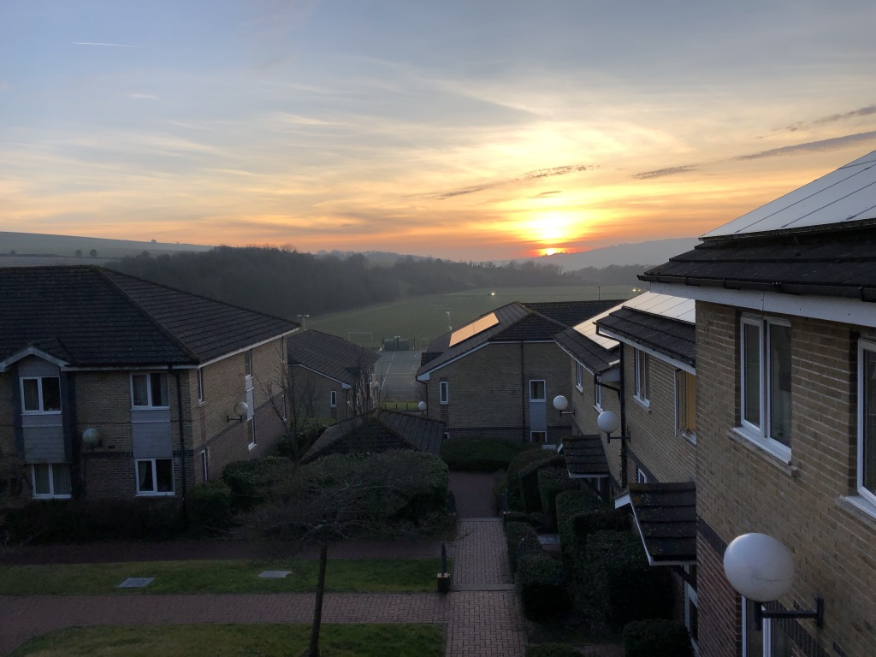
The Paddock Fields Halls of Residence is where all international students are given accommodations. The halls are co-ed flats with eight rooms (each room has their own en-suite bathroom) and a common room. All eight flatmates need to share 3 mini-fridges and 3 mini-freezers. Because of this, when doing groceries, they need to be done in smaller loads and more frequently. Additionally, because the downtime between the previous students moving out and second semester move in day is so short, sometimes certain things are not completely fixed or cleaned properly. This being said, the reception desk is very responsive and will fix any issues in a timely manner.
Paddock Fields has paid laundry facilities on site that function using the Circuit app. I would recommend getting a drying rack for your dorm room as the laundry room can get quite busy and it can be expensive. For an average load of laundry it is 3.60 GBP to wash and 1.10 GBP to dry.
As indicated in the above budget plan, the cost of rooming in the flat is approximately 2660 GBP. These particular halls are set up in the Falmer campus which is about a 20 minute bus ride to the business school campus and about a 30 minute bus ride to the city centre. Because of this, I would strongly recommend getting a student bus pass.

My Experience in Brighton
England is known to be one of the rainiest countries and although its rained quite a bit, I must say that in Brighton it is particularly windy. Even though Ottawa can be very cold, because Brighton is by the water and the residences are set up in the mountains, there is a cold damp wind chill in the winter. This being said, nothing beats being able to go to the seaside, taking a ride on the British Airways I360 or being by the Brighton Pier and even the Marina. Brighton also has great nightlife and dining. The vibrant city is known for what are called the lanes and there, you can find some of the best food in Brighton. One of my personal favourites is Cloud 9 bakery which has some of the best cupcakes in town. At Shooshh you can also find some of the newest music and relatively inexpensive drinks.

Going into this experience I did not know what to expect of my flatmates. I can honestly say that I have met some of my best friends in the Paddock fields residence. I would say that you shouldn’t really expect to really interact with locals in classes or in residence as they seem to be in separate classes from the international students. This being said, you do get to meet people from different countries which is a very enriching experience. I would recommend holding off on booking any trips before you go on exchange because you will have the opportunity to travel with your new friends. I have been able to visit multiple countries and with the Easter break being so long, it is a great time to visit more of Europe.

